1. DB design
2. Diagram

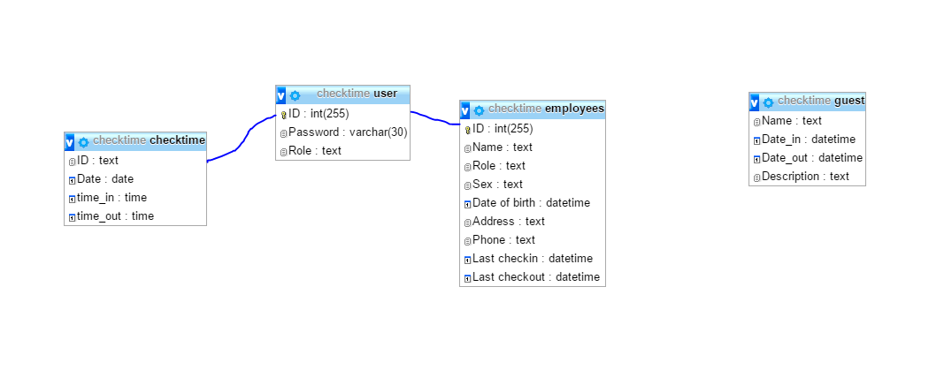

1. Description

-Table employees:

|  |  |  |  |  |
| --- | --- | --- | --- | --- |
| No. | Field | Type | Length | Description |
| 1 | ID | Int | 255 | Mã nhân viên |
| 2 | Name | Text | 50 | Tên nhân viên |
| 3 | Sex | Text | 10 | Giới tính |
| 4 | Date of birth | Datetime | 30 | Ngày sinh |
| 5 | Address | Text | 100 | Địa chỉ |
| 6 | Phone | Text | 15 | SĐT |
| 7 | Last checkin | Datetime | 30 | Lần vào cuối |
| 8 | Last checkout | datetime | 30 | Lần ra cuối |

-Table user:

|  |  |  |  |  |
| --- | --- | --- | --- | --- |
| No. | Field | Type | Length | Description |
| 1 | ID | Int | 255 | Mã người dùng |
| 2 | Password | Varchar | 50 | Mật khẩu |
| 3 | Role | text | 30 | Vai trò |

-Table: checktime

|  |  |  |  |  |
| --- | --- | --- | --- | --- |
| No. | Field | Type | Length | Description |
| 1 | ID | Int | 255 | Mã người dùng |
| 2 | Date | Date | 30 | Ngay` |
| 3 | time_in | time | 30 | Thoi gian vao |
| 4 | Time_out | Time | 30 | Thoi gian ra |

-Table Guest:

|  |  |  |  |  |
| --- | --- | --- | --- | --- |
| No. | Field | Type | Length | Description |
| 1 | Name | Text | 50 | Tên khách |
| 2 | Date_in | Datetime | 30 | Thời gian vào |
| 3 | Date_out | datetime | 30 | Thời gian ra |

1. screen transition (wireframe)
2. For staff

-Log in:

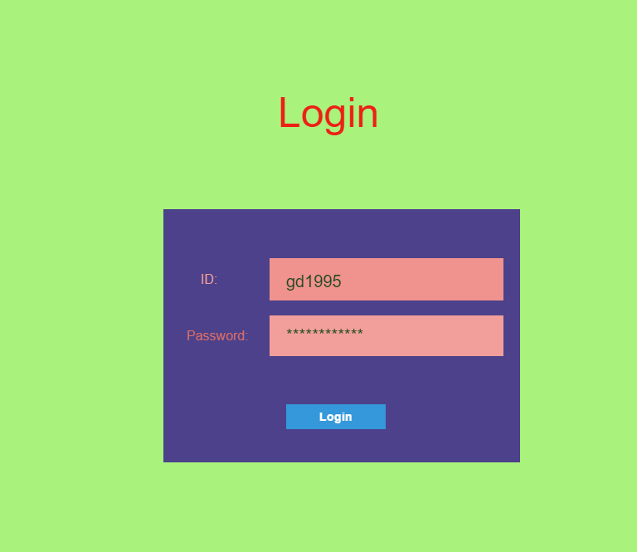

* See information of staff:

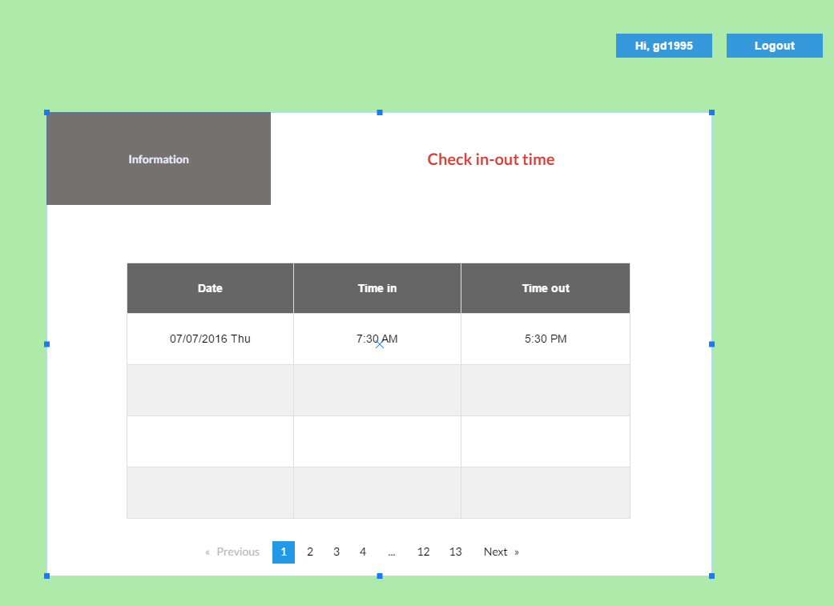

1. For admin:

-log in:



-infor:

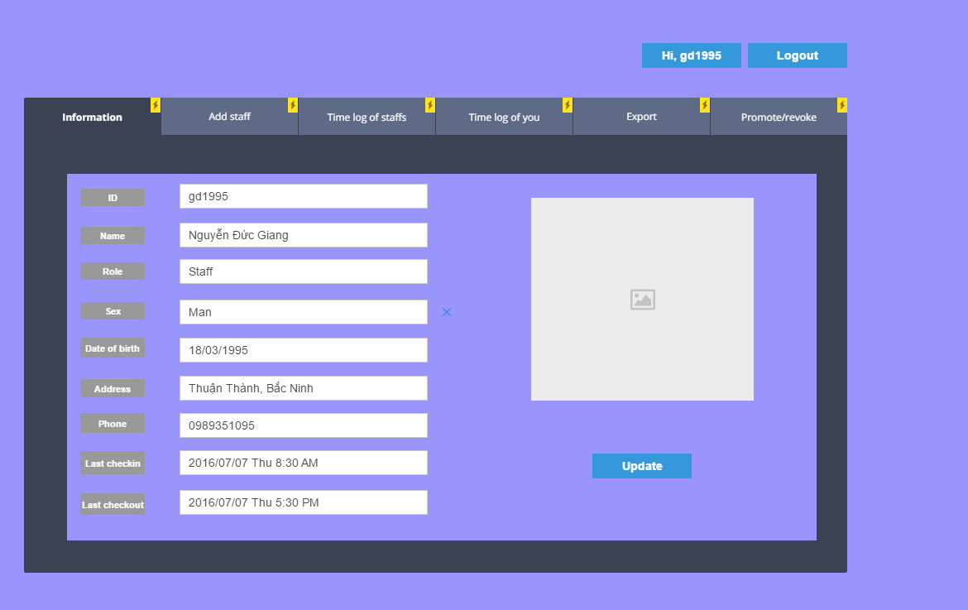

-add staff:

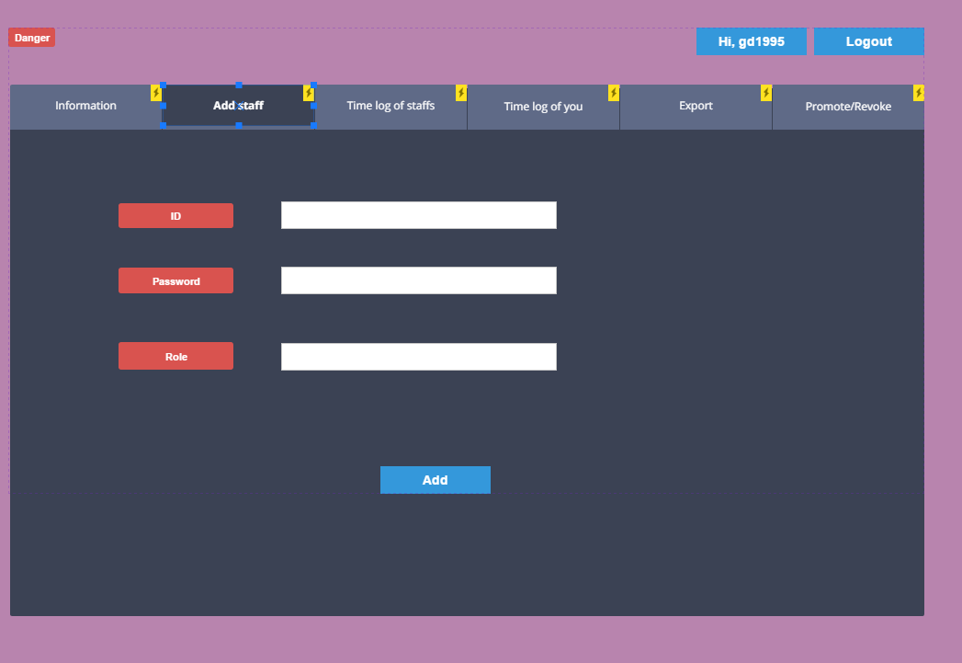

-see time log of staffs:

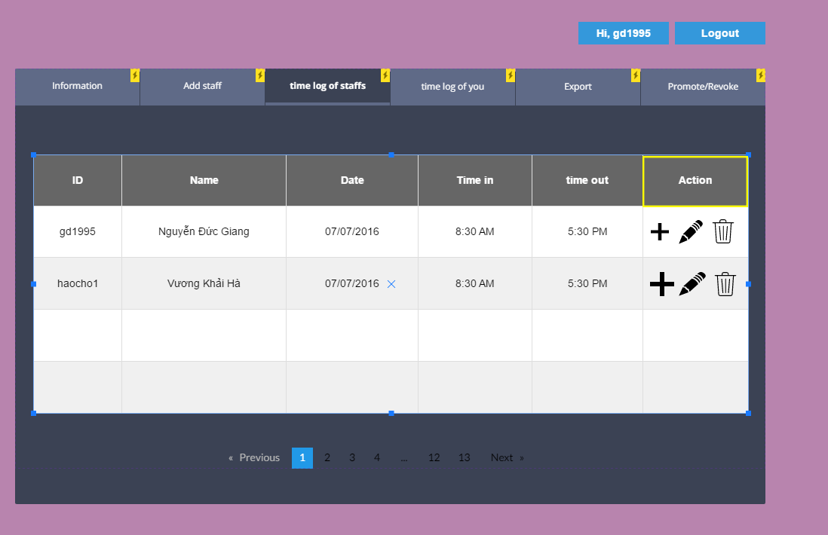

-time log of admin:

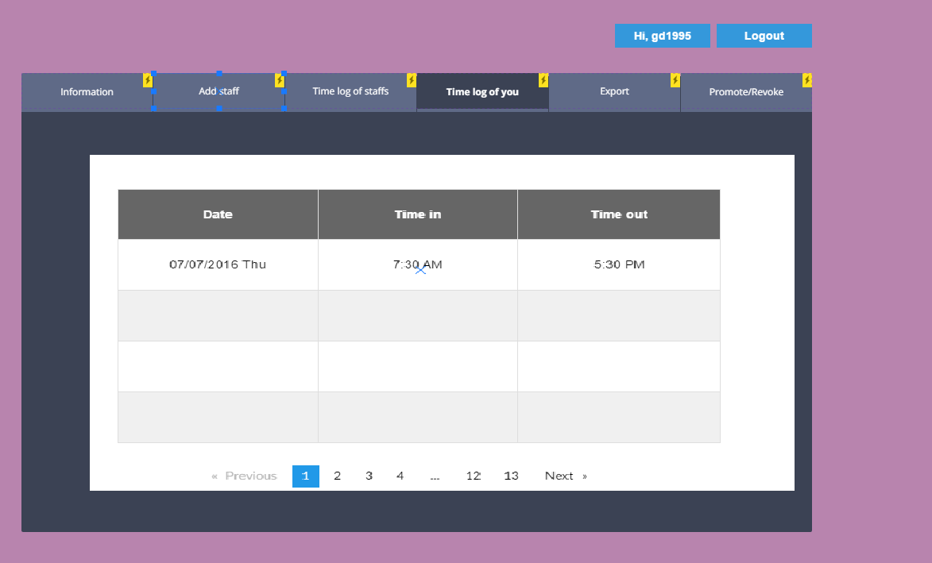

1. WBS

